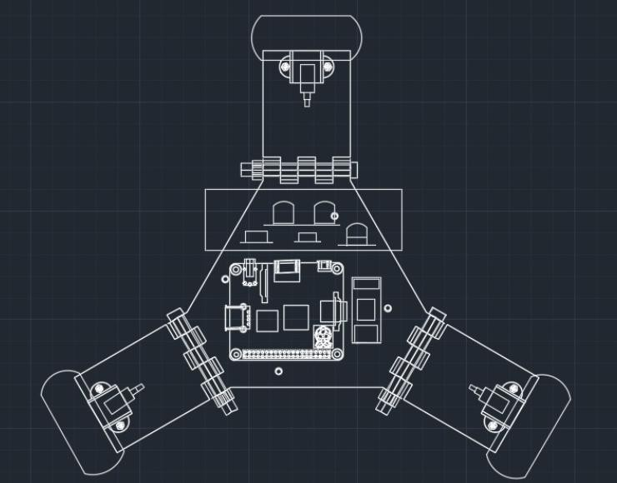

TOP VIEW
The novelty resides in the shape and configuration of the “ADJUSTABLE FIDGET SPINNER BASE FOR PIPE CLIMBING” as illustrated

No claim is made by virtue of this registration in respect of any mechanical or other action of any mechanism whatever or in respect of any mode or principle of construction of the Article

No claim is made by virtue of this registration to any right to the exclusive use of the words, letters, numbers, Color, or trademarks appearing in the representation.

Dated: 13 MAY 2025 Sign, (Applicant)
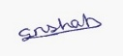
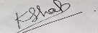
Shah Shashwat Nimesh Shah Kruti Bhavesh
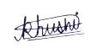
Jobanputra Khushi Dharmendra
Gupta Manasvi Ganesh 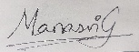
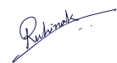
Karani Ruhina

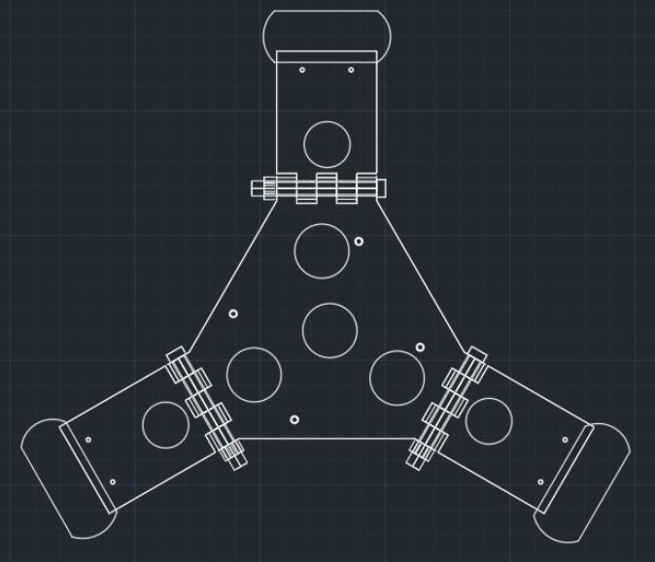

BOTTOM VIEW
The novelty resides in the shape and configuration of the “ADJUSTABLE FIDGET SPINNER BASE FOR PIPE CLIMBING” as illustrated

No claim is made by virtue of this registration in respect of any mechanical or other action of any mechanism whatever or in respect of any mode or principle of construction of the Article

No claim is made by virtue of this registration to any right to the exclusive use of the words, letters, numbers, Color, or trademarks appearing in the representation.

Dated: 13 MAY 2025 Sign, (Applicant)
Shah Shashwat Nimesh Shah Kruti Bhavesh
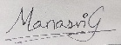
Jobanputra Khushi Dharmendra
Gupta Manasvi Ganesh
Karani Ruhina

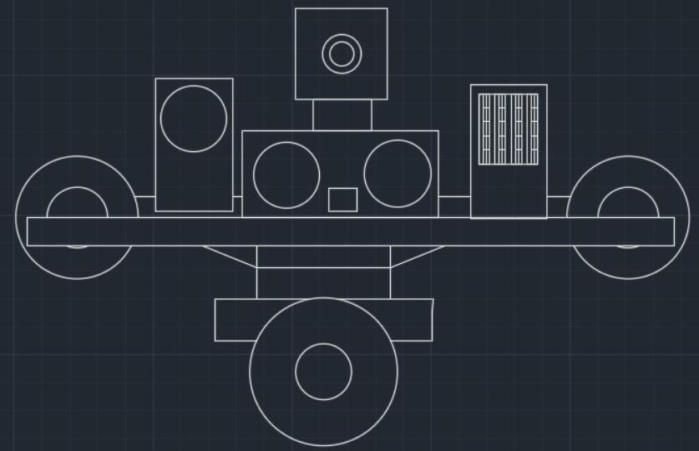

FRONT VIEW

The novelty resides in the shape and configuration of the “ADJUSTABLE FIDGET SPINNER BASE FOR PIPE CLIMBING” as illustrated

No claim is made by virtue of this registration in respect of any mechanical or other action of any mechanism whatever or in respect of any mode or principle of construction of the Article

No claim is made by virtue of this registration to any right to the exclusive use of the words, letters, numbers, Color, or trademarks appearing in the representation.

Dated: 13 MAY 2025 Sign, (Applicant)
Shah Shashwat Nimesh Shah Kruti Bhavesh
Jobanputra Khushi Dharmendra
Gupta Manasvi Ganesh
Karani Ruhina

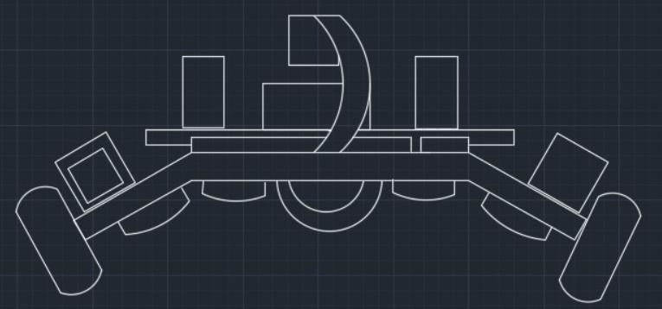

REAR VIEW
The novelty resides in the shape and configuration of the “ADJUSTABLE FIDGET SPINNER BASE FOR PIPE CLIMBING” as illustrated

No claim is made by virtue of this registration in respect of any mechanical or other action of any mechanism whatever or in respect of any mode or principle of construction of the Article

No claim is made by virtue of this registration to any right to the exclusive use of the words, letters, numbers, Color, or trademarks appearing in the representation.

Dated: 13 MAY 2025 Sign, (Applicant)
Shah Shashwat Nimesh Shah Kruti Bhavesh
Jobanputra Khushi Dharmendra
Gupta Manasvi Ganesh
Karani Ruhina

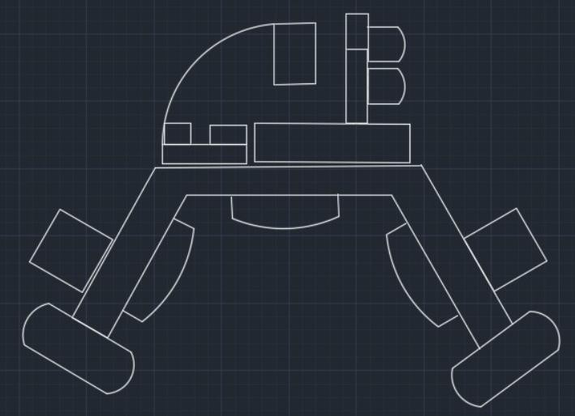

LEFT VIEW
The novelty resides in the shape and configuration of the “ADJUSTABLE FIDGET SPINNER BASE FOR PIPE CLIMBING” as illustrated
No claim is made by virtue of this registration in respect of any mechanical or other action of any mechanism whatever or in respect of any mode or principle of construction of the Article

No claim is made by virtue of this registration to any right to the exclusive use of the words, letters, numbers, Color, or trademarks appearing in the representation.

Dated: 13 MAY 2025 Sign, (Applicant)
Shah Shashwat Nimesh Shah Kruti Bhavesh
Jobanputra Khushi Dharmendra
Gupta Manasvi Ganesh
Karani Ruhina

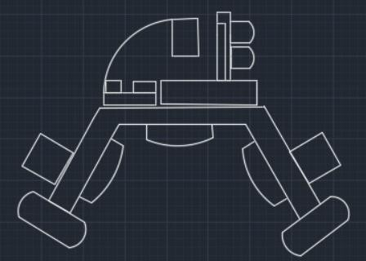

RIGHT VIEW
The novelty resides in the shape and configuration of the “ADJUSTABLE FIDGET SPINNER BASE FOR PIPE CLIMBING” as illustrated

No claim is made by virtue of this registration in respect of any mechanical or other action of any mechanism whatever or in respect of any mode or principle of construction of the Article

No claim is made by virtue of this registration to any right to the exclusive use of the words, letters, numbers, Color, or trademarks appearing in the representation.

Dated: 13 MAY 2025 Sign, (Applicant)
Shah Shashwat Nimesh Shah Kruti Bhavesh
Jobanputra Khushi Dharmendra
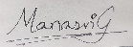
Gupta Manasvi Ganesh
Karani Ruhina

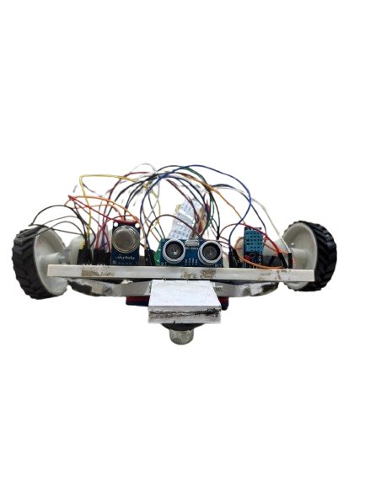

PERSPECTIVE VIEW
The novelty resides in the shape and configuration of the “ADJUSTABLE FIDGET SPINNER BASE FOR PIPE CLIMBING” as illustrated

No claim is made by virtue of this registration in respect of any mechanical or other action of any mechanism whatever or in respect of any mode or principle of construction of the Article

No claim is made by virtue of this registration to any right to the exclusive use of the words, letters, numbers, Color, or trademarks appearing in the representation.

Dated: 13 MAY 2025 Sign, (Applicant)
Shah Shashwat Nimesh Shah Kruti Bhavesh
Jobanputra Khushi Dharmendra
Gupta Manasvi Ganesh
Karani Ruhina

